**Sheet 1: Linear discrete systems**

**Q1.** Draw a block diagram of digital feedback control system. Show the type of the signal at each point on the block diagram, whether continuous, discrete, and ZOH (output of D/A) signals.

**Q2.** What are the advantages of digital over analog control systems?

**Q3.** Explain how to adjust the sampling interval using both timer interrupts and dummy code.

**Q4.** Solve the following difference equations:



**Q5.** Given the following difference equation

$$y_{k}=0.5y_{k-1}+0.25y_{k-2}+u_{k-1}$$

1. Find the transfer function Y(z)/U(z).
2. How many delay samples are there between the input and output?
3. If the system is stable, find its dc gain.
4. Find the first four samples of the impulse response of the system.

**Answer:** Dc gain = 4, impulse response: 0, 1, 0.5, 0.25.

**Q6.** Consider a discrete damped sinusoid:

$$e_{k}=e\left(k\right)=r^{k}\sin\left(kθ\right)={0.5}^{k}sin⁡\left(k\frac{π}{2}\right)$$

Plot the signal and then find:

1. The z-transform of **ek**,
2. The pole/zero locations.
3. The number of samples per cycle.

**Q7.** For the two poles s = -1, -2 in the *s*-plane, what are the equivalent poles in the z-plane? Which of these two poles is faster in response? Which is the more dominant?

**Q8.** Find the discrete approximation of the following continuous-time transfer function using: (i) Forward rectangular (ii) Backward rectangular and (iii) Trapezoidal rules.

$$H\left(s\right)=10\frac{s+1}{s+10}$$

**Q9.** What is the advantage of zero-order hold (ZOH) reconstruction over the reconstruction using the ideal low pass filter (LPF)?

**Q10.** Find the transfer function Y(z)/U(z) if the relationship between the input uk and the output yk is given by the following summation:

$$y_{k}=\sum_{i=0}^{k}{u_{i}}$$

Answer: We have:

$$y_{k}=\sum_{i=0}^{k}{u_{i}}, y_{k-1}=\sum_{i=0}^{k-1}{u_{i}}$$

By subtracting, we obtain

$$y_{k}-y_{k-1}=u_{k}$$

and by taking z-transoform, we obtain the transfer function

$$\frac{Y\left(z\right)}{U\left(z\right)}=\frac{1}{1-z^{-1}}=\frac{z}{z-1}.$$

**Sheet 2: The z-Transform**

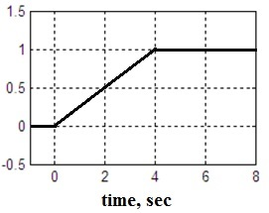**Q1.** The following continuous-time signal is sampled every 1 second.

1. Find, in closed form, the z-transform of the sequence obtained.
2. Check your answer in part (a) using long-division.

**Answer**

The sequence obtained by sampling is {0, 0.25, 0.5, 0.75, 1.0, 1.0,….}

1. The z-transform is

$$Y\left(z\right)=0.25z^{-1}+0.5z^{-2}+0.75z^{-3}+z^{-4}+z^{-5}+z^{-6}+…$$

$$=\frac{0.25}{z}+\frac{0.5}{z^{2}}+\frac{0.75}{z^{3}}+z^{-4}\left(1+z^{-1}+z^{-2}+…\right)$$

$$=\frac{0.25z^{2}+0.5 z+0.75}{z^{3}}+\frac{z^{-3}}{z-1}=0.25 \frac{z^{3}+z^{2}+z+1}{z^{3}(z-1)}$$

**Q2.** Using the s- to z-transform tables, find the z-transform of the following function, assuming that T = 0.5 sec:



**Q3.** Use the z-differentiation rule to find the z-transform of the following time sequences.



Check your answer using MATLAB command **ztrans**. For example, we can solve (b) using the following commands:

syms a k z

xk = k*exp(-a*k);

xz = ztrans(xk,k,z)

**Q4.** Determine the final value of the sequence whose z-transform is:

$$X\left(z\right)=\frac{2}{1-z^{-1}}-\frac{1}{1-e^{-2}z^{-1}}$$

**Q5.** Find the inverse z-transform of *X*(*z*) using either long division or partial fraction method. Find also the steady state value of *x*(*k*).



**Q6.** Given the following signal in the z-domain



1. What is the final value of y(k)?
2. Find the inverse z-transform of Y(z) in closed form.

**Answer:** As *Y*(*z*) has a pole at *z* = 2 (outside the unit circle), the final value theorem is not applicable. The final value of *y*(*k*) is ∞.



2-

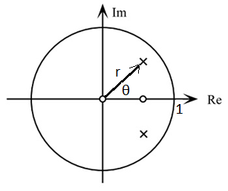Again, we can see that the final value of y(k) is ∞.

**Q7.** A system has two poles, two zeros and a dc gain of 10. The location of the poles and zeros are as shown, where

$$r=\frac{1}{\sqrt{2}},θ=45°.$$

1. Find the transfer function of the system.
2. Find the first four samples of the unit pulse response of the system.

**Answer**



* From the given figure, the zeros are:



and the poles are:

* Hence the transfer function is



* The dc gain of this G(z) = G(1) = 1. For the transfer function to have a dc gain of 10, the required transfer function should be:



* Using long division, the pulse response is given by:



* That is, y(0) = 10, y(1) = 5, y(2) = 0, y(3) = -2.5.

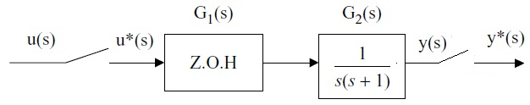**Q8.** Calculate the pulse response of the following system assuming that the sampling period T = 1sec.

**Answer:**



The transfer function of the ZOH is

For this system, we have



where (T=1)



Using partial fractional expansion



From the z-transform tables



For a pulse input, U(z) = 1, the pulse response will be given by



After long division, we obtain the time response

$$y\left(k\right)=0.368δ\left(k-1\right)+0.768δ\left(k-2\right)+0.915δ\left(k-3\right)+…$$

**Q9.** Calculate the output response of the following sampled-data system to a unit step input. Assume that *T* = 1 s.

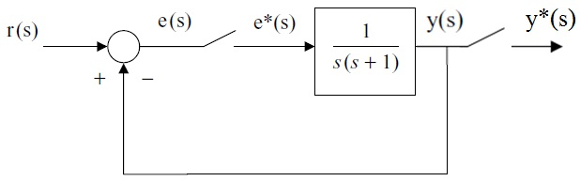

**Answer:**

The transfer function of the closed-loop system is



Substituting in y(z) gives



Since T = 1,



**Q10.** Find the first three samples of the step response *y*(*t*) for the following system. Use sample period T = 1.

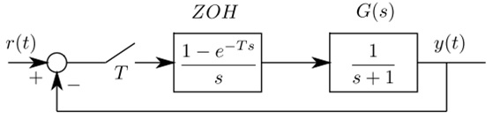

**Sheet 3: Stability**

**Q1.** Check the stability of the discrete-time control systems having the following characteristic equations:

$$\left(a\right) z^{2}-0.81=0$$

$$\left(b\right){ z}^{2}-z+2=0$$

$$\left(c\right) {z^{3}-1.1z}^{2}-0.1z-0.2=0$$

**Q2.** Determine whether the system having the following characteristic polynomial is stable:



**Answer: Jury’s stability conditions are:**



The 4th condition requires constructing Jury’s array:

**a0 a1 a2 a3**

-0.1 3.1 -3.1 1

1 -3.1 3.1 -0.1

-0.99 - -2.79

As |-0.99|<|-2.79|, this condition is not satsified → the system is unstable.

**Q3.** Consider the discrete-time control system described by the difference equation,

$$y_{k}-0.6y_{k-1}-0.8y_{k-2}+0.6y_{k-3}-0.1y_{k-4}=x_{k}$$

where, x(k) is the input of system and y(k) is the output of system. Determine the stability of the system.

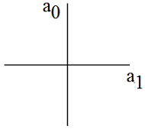**Q4.** A second-order discrete-time system has the following characteristic equation:



Show the region in the given a0–a1 plane for which the given system is stable.

**Q5.** Consider the shown digital control system where

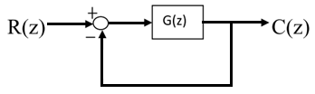

$$G\left(z\right)=\frac{K(z-0.2)}{{\left(z-0.8\right)}^{2}}$$

1. Find the maximum gain *K* so the closed-loop system is stable.
2. For **K = 1**, find the steady state value of both the output C and error for a unit-step input. How to remove the steady state error?

**Answer**

1. The closed-loop transfer function Y(z) / R(z).

$$G_{cl}\left(z\right)=\frac{C\left(z\right)}{R\left(z\right)}=\frac{G\left(z\right)}{1+G(z)}=\frac{K(z-0.2)}{{\left(z-0.8\right)}^{2}+K(z-0.2)}$$

The characteristic equation is

$$F\left(z\right)={\left(z-0.8\right)}^{2}+K\left(z-0.2\right)=0$$

$$F\left(z\right)=z^{2}+\left(K-1.6\right)z+(0.64-0.2K)=0$$

Let us apply Jury test:

$$F\left(1\right)=1+K-1.6+0.64-0.2K>0 → K>-0.05$$

$$F\left(-1\right)=1-K+1.6+0.64-0.2K>0 → K<2.7$$

$$a_{2}>\left|a_{0}\right|$$

$$1>\left|0.64-0.2K\right|$$

$$1>0.64-0.2K>-1$$

$$-1.8<K<8.2$$

Combining all inequalities, the maximum for K is **2.7**.

1. The steady state output can be found as:

$$c_{ss}=\lim_{z→1}\left(1-z^{-1}\right)C\left(z\right)={\lim_{z→1}\left(1-z^{-1}\right)G_{cl}\left(z\right)R\left(z\right)}$$

$$=\lim_{z→1}\left(1-z^{-1}\right)\frac{K\left(z-0.2\right)}{{\left(z-0.8\right)}^{2}+K\left(z-0.2\right)}\frac{z}{z-1}=0.952$$

$$→e_{ss}=1-c_{ss}=0.048 ≈5\%$$

In order to remove the steady state error, we need to use an integral control action.

**Q6.** Given the following discrete-time control system (with sampling period T=1sec):

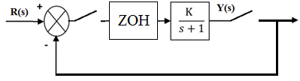

1. Find the transfer function *Y*(*z*)/*R*(*z*).
2. What is the maximum value of *K* that keeps the closed-loop system stable?

**Answer**

1. The closed loop is given by



1. For stability, we have one closed loop pole:

z = 0.368-0.632K

|0.368-0.632K| < 1

-1 < 0.368-0.632K < 1

-1.368 < -0.632 K < 0.632

2.16 > K > -1

**Sheet 4: Controller Design**

**Q1.** The continuous-time PID controller has the transfer function



1. Derive the equivalent discrete-time controller transfer function using the backward Euler approximation.
2. Write down a pseudo code to implement this PID controller on a microcontroller.

**Answer:**

The discrete PID controller is given by the following transfer function:



**Q2.** Design a digital controller, *D*(*z*), such that the poles of the following closed-loop system are placed at 0.4 ± j0.4 in the z-plane. The steady-state error in the step response must be zero.

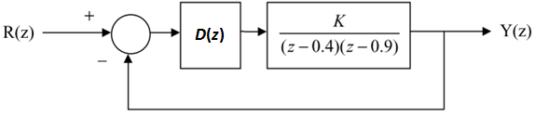

**Answer:**

The desired closed-loop transfer function takes the form:



As the process has a two-samples delay, T(z) must have at least the same delay, i.e.,



The error is given by





**Q3.** The open-loop transfer function of a plant is given by:



Which is to be preceded by a ZOH circuit.

1. Design a dead-beat digital controller for the system. Assume that *T*=1 s.
2. Plot the time response of the system.

**Q4.** Consider the transfer function of the following process (to be preceded by a ZOH with a sample period T = 1 s),



Design a controller so that the system response to a unit step input is

*y*(*k*) = {0 , 0.4, 1, 1, …}

**Q5.** Consider the following closed-loop system.

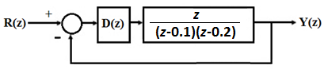

1. Design a digital controller ***D***(*z*) to achieve a deadbeat response for step set-points.
2. Draw the unit step and the unit ramp responses of the closed-loop system.

**Q6.** Consider the following discrete-time closed-loop system, with a sampling period, ***T* = 1 second**:

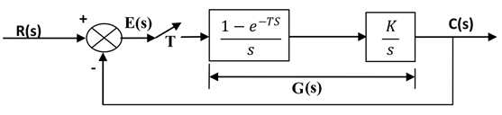

1. Find the discrete-time transfer function, *G*(*z*), of the plant, *G*(*s*), and the closed-loop system.
2. What is the maximum *K* that keeps the closed-loop system stable?
3. Using partial fraction, obtain the output sequence *c*(*k*) for a unit-step input, assuming that *K*=1.5. Find the steady-state error.
4. Design a deadbeat controller for the process *G*(*z*), where *K*=1.5. What is the type of the controller needed?

**Answer**

$G\left(s\right)=\frac{1-e^{-Ts}}{s}\frac{K}{s} → G\left(z\right)=\left(1-z^{-1}\right)Z\left\{\frac{K}{s^{2}}\right\}=\frac{\left(1-z^{-1}\right)KTz}{{\left(z-1\right)}^{2}}=\frac{KT}{z-1}$

$$G_{cl}\left(z\right)=\frac{G\left(z\right)}{1+G(z)}=\frac{K}{z-1+K}$$

1. The characteristic equation is

$$z-1+K=0 → z=1-K$$

For stability,

$$|1-K|≤1$$

$$-1≤1-K≤1$$

$$2≥K≥0$$

1. The output for a unit step input is

$C\left(z\right)=G_{cl}\left(z\right)R\left(z\right)=\frac{1.5}{z+0.5}\frac{z}{z-1}$

$\frac{C\left(z\right)}{z}=\frac{1.5}{z+0.5}\frac{1}{z-1}=\frac{1}{z-1}-\frac{1}{z+0.5} → c\left(k\right)=1-{\left(-0.5\right)}^{k}$

Noting that *c*(∞)=1, steady state error *e*(∞) = r(∞) – c(∞) = 1-1=0.

1. Deadbeat controller design:

$$D\left(z\right)=\frac{1}{G\left(z\right)}\frac{T\left(z\right)}{1-T(z)}=\frac{z-1}{1.5}\frac{z^{-k}}{1-z^{-k}}=\frac{{z^{1-k}-z}^{-k}}{1.5(1-z^{-k})}$$

For the controller to be realizable, 1- *k* ≤ 0, hence *k* = 1. This gives a proportional controller.

$$D\left(z\right)=\frac{{1-z}^{-1}}{1.5(1-z^{-1})}=0.667$$

1. Find the discrete-time closed-loop transfer function.
2. Find the steady-state gain of the closed-loop.

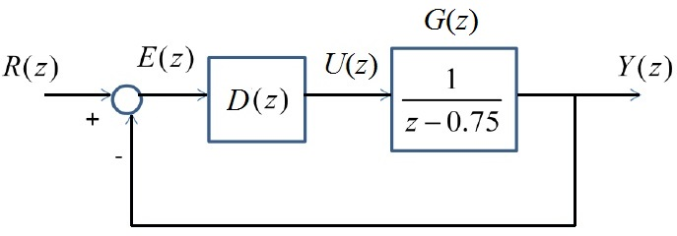**Q7.** Consider the given closed-loop control system

1. Is the plant stable? Why?
2. Find the dc gain of plant G(z) and its time delay?
3. Does the plant have an integrator? Why?
4. Assume *D*(*z*) = *K*, i.e. a proportional gain. Determine the maximum value of *K* so that the closed-loop system is stable.
5. Design a deadbeat controller *D*(*z*) for the system.
6. Draw the discrete-time step response **y** of the closed-loop system using the designed **deadbeat** controller.
7. Find, **in closed-form**, and then draw the control signal **u** for the same step input.

**Answer**

1. The plant is stable because it has one pole (z = 0.75) which lies inside the unity circle.
2. The dc gain of the plant G(z) = G(1) = 1/(1-0.75) = 4.

The time delay of the process is one because the order of denominator is larger than that of the numerator by 1.

1. The plant does not contain an integrator because it has no pole at 0.
2. The characteristic equation is given by

$$1+\frac{K}{z-0.75}=0, →z-0.75+K=0 →z=0.75-K$$

For stability

$$|0.75-K|≤1$$

$$-1≤0.75-K≤1$$

$$1.75≥K≥-0.25$$

1. For deadbeat response, the desired closed loop transfer function is *T*(*z*) = *z*-1. Therefore, the transfer function of the controller D(z) is



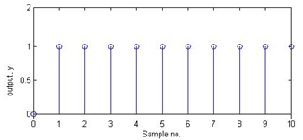

1. The closed-loop step sequence is as shown.
2. Here, we first find the transfer function U(z)/R(z)



The control signal for a step input is



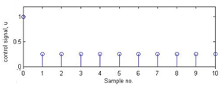

The control signal sequence is thus {1, 0.25. 0.25, 0.25, ……}

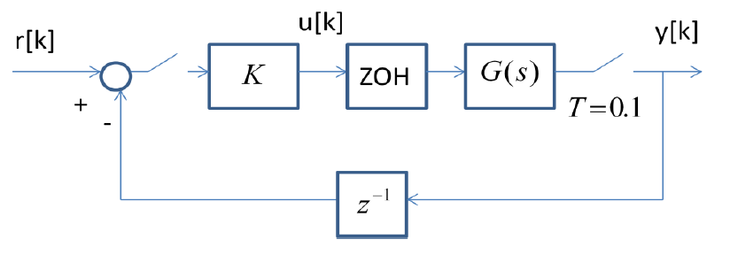**Q8.** Consider the digital control system shown, where



1. Find the discrete equivalent of the G(s) preceded by the ZOH.
2. Find the closed-loop transfer function and its dc gain in terms of the controller gain *K*.
3. Find the maximum value of *K* that keeps the system stable.
4. If there is no delay *z*-1 in the feedback path, what is the maximum *K* for stability?

**Answer**

1. The plant is given by
$$G\left(z\right)=\frac{1-δ}{z-δ}, δ=\exp\left(-0.1\right)=0.905$$

2. The closed-loop transfer function
$$G_{cl}\left(z\right)=\frac{KG\left(z\right)}{1+Kz^{-1}G\left(z\right)}=\frac{K\left(1-δ\right)z}{z\left(z-δ\right)+K\left(1-δ\right)} →K_{dc}=\frac{K}{1+K}$$

3. The characteristic equation:

$${F\left(z\right)=z}^{2}-δz+K\left(1-δ\right)=0$$

Let us apply Jury’s test

$$F\left(1\right)=1-δ+K\left(1-δ\right)>0 → K>-1$$

$$F\left(-1\right)=1+δ+K\left(1-δ\right)>0 → K>-\frac{δ+1}{δ-1}=-20.05$$

$$a_{2}>\left|a_{0}\right|$$

$$1>|K\left(1-δ\right)|$$

$$1>K\left(1-δ\right)>-1$$

$$10.5>K>-10.5$$

Therefore, the maximum value of *K* allowed is 10.5.

1. For a system without time delay in the feedback path, we expect the system to have larger stability margin.

The characteristic equation for this system is:

$$F\left(z\right)=z-δ+K\left(1-δ\right)=0$$

We have only one pole which should be inside the unit circle for stability, i.e.

$$\left|δ-K\left(1-δ\right)\right|<1$$

$$-1< δ-K\left(1-δ\right)<1$$

$$-1- δ<-K\left(1-δ\right)<1- δ$$

$$\frac{1+δ}{1-δ}>K>-1 → K<20.05$$

As we see, the maximum gain rises to 20.05.

**Sheet 5: State Space Design**

**Q1.** Find the eigenvalues of the following matrix, $A=\left(\begin{matrix}1 & 2 & 1 \\ 2 & 1 & 1 \\ 1 & 0 & 2\end{matrix}\right).$

**Q2.** Given the following matrix ***A*** and vector ***v***, determine if ***v*** is an eigenvector of ***A***. If so, what is the corresponding eigenvalue?



Answer: if we multiply the matrix by the vector *Av =* 4*v.* Therefore v is an eigenvector of A, and the corresponding eigenvalue is 4.

**Q3.** Write the continuous-time transfer function of the following state space description:



Next, define a new state **z1 = 2x1** and **z2 = 3x2**. Write the state space model in terms of the new states **z1** and **z2**.

**Q4.** Find a discrete-time state space model of the following continuous-time system (using a sampling period of 1 sec). Check with MATLAB.



**Q5.** Find a discrete-time state space description of a dc motor shown in the following block diagram (using a sampling period of 1 sec).

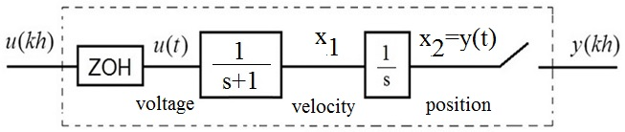

**Q6.** Given the following discrete-time system:

$$x\left(k+1\right)=\left(\begin{matrix}-0.5 & 1 \\ 0 & 1\end{matrix}\right)x\left(k\right)+\left(\begin{matrix}1 \\ 0\end{matrix}\right)u\left(k\right),$$

$$y\left(k\right)=\left(\begin{matrix}1 & 0\end{matrix}\right)x\left(k\right).$$

1. Find the eigenvalues of the system.
2. Find the transfer function of the system.

**Answer: $H\left(z\right)=C{\left(zI-Φ\right)}^{-1}Γ=\frac{1}{z+0.5}$**

**Q7.** Check the controllability of the following discrete-time systems

$$x\left(k+1\right)=\left(\begin{matrix}1 & 0 \\ 0 & 2\end{matrix}\right)x\left(k\right)+\left(\begin{matrix}0 \\ 1\end{matrix}\right)u\left(k\right).$$

**Q8.** Given the following discrete-time state space model:

$$x\left(k+1\right)=\left(\begin{matrix}1 & 0 \\ 1 & 2\end{matrix}\right)x\left(k\right)+\left(\begin{matrix}0 \\ 1\end{matrix}\right)u\left(k\right),$$

$$y\left(k\right)=\left(\begin{matrix}1 & 0\end{matrix}\right)x\left(k\right).$$

1. Check if the system is controllable.
2. If the system is controllable, design a feedback controller to obtain the eigenvalues {0.3±j0.3}. Check using MATLAB.

**Q9.** Given the following discrete-time state space model:



1. Check if the following pair is controllable.
2. If the system is controllable, design a feedback controller to obtain the eigenvalues {0.2, 0.3±j0.3}. Check using MATLAB.

**Q10.** Check the observability of the following discrete-time system

$$x\left(k+1\right)=\left(\begin{matrix}1 & 1 \\ 0 & 2\end{matrix}\right)x\left(k\right)+\left(\begin{matrix}1 \\ 1\end{matrix}\right)u\left(k\right),$$

$$y\left(k\right)=\left(\begin{matrix}1 & 0\end{matrix}\right)x\left(k\right).$$

If the system is observable, design a state observer for the system. The observer eigenvalues are to be located at 0.1, 0.2. Check your answer with MATLAB.

**Q11.** Given the following state space model:

$$x\left(k+1\right)=\left(\begin{matrix}3 & 0 \\ 0 & 2\end{matrix}\right)x\left(k\right)+\left(\begin{matrix}1 \\ 1\end{matrix}\right)u\left(k\right),$$

$$y\left(k\right)=\left(\begin{matrix}1 & 1\end{matrix}\right)x\left(k\right).$$

A state observer whose gain matrix $L={(6.875, -2.625)}^{T}$ has been designed for the system. Find the eigenvalues of the observer.

**Q12.** Given the following discrete-time system in state space form:

$$x\left(k+1\right)=\left(\begin{matrix}1 & -1 \\ 1 & 0\end{matrix}\right)x\left(k\right)+\left(\begin{matrix}0 \\ 1\end{matrix}\right)u\left(k\right),$$

$$y\left(k\right)=\left(\begin{matrix}1 & 0\end{matrix}\right)x\left(k\right).$$

1. Check if the system is controllable and observable.
2. Design a state feedback controller with closed-loop eigenvalues 0.5 and 0.4.
3. Design a state observer having eigenvalues of 0.1 and 0.2.
4. Draw the block diagram of the whole system (state feedback plus observer).

Answer:

1. The controllability matrix:



The observability matrix:



1. The state feedback design: For the given eigenvalues, the desired characteristic polynomial is

$$Δ=\left(λ-0.5\right)\left(λ-0.4\right)=λ^{2}-0.9λ+0.2$$

The closed-loop state matrix is

$$Φ_{cl}=Φ-ΓK=\left(\begin{matrix}1 & -1 \\ 1 & 0\end{matrix}\right)-\left(\begin{matrix}0 \\ 1\end{matrix}\right)\left(\begin{matrix}k_{1} & k_{2}\end{matrix}\right)=\left(\begin{matrix}1 & -1 \\ 1-k_{1} & -k_{2}\end{matrix}\right)$$

By equating the characteristic polynomial $\left|λI-Φ_{cl}\right|$ to the desired polynomial

$$\left|\begin{matrix}λ-1 & 1 \\ k_{1}-1 & λ+k_{2}\end{matrix}\right|=λ^{2}-0.9λ+0.2$$

$$λ^{2}+\left(k_{2}-1\right)λ-k_{2}-k_{1}+1=λ^{2}-0.9λ+0.2$$

We obtain $k_{1}=0.7$ and $k_{2}=0.1.$

1. Observer design:

For the given eigenvalues, the desired characteristic polynomial is



The closed-loop state matrix for the observer is



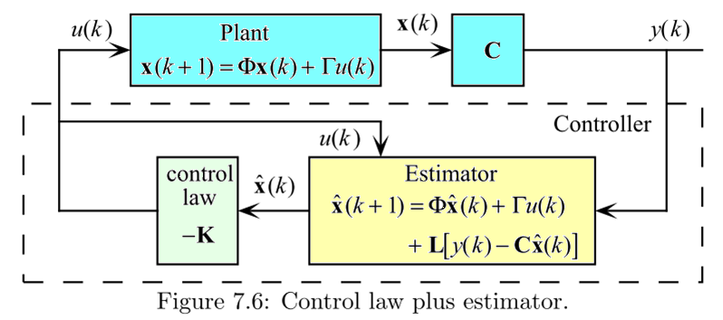

**Sheet 6: System Identification**

**Q1.** Consider the following model



where *y*(*k*) is the system output at instant *k*, and *e*(*k*) is an equation error. Given the following input output data,

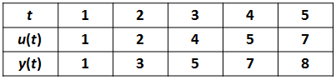

1. Deduce the matrix Φ.
2. Calculate the least squares estimate of a and b.
3. Calculate the model output.
4. Calculate the residuals.

**Q2.** Consider the following model:



An experiment is done on the system to estimate the parameters, *a* and *b*. The following input-output data were recorded:

|  |  |  |  |  |
| --- | --- | --- | --- | --- |
| **t** | **1** | **2** | **3** | **4** |
| **u(t)** | **1** | **1** | **0** | **0** |
| **y(t)** | **0** | **2** | **1** | **0** |

1. Using the given data, write down the equations in matrix form.
2. Determine the least squares estimate of *a* and *b*.
3. Find the model output and the residuals.
4. What is the transfer function of the model obtained?
5. Is the model stable? Why?

**Answer**







1. The model output



The residual is



1. The transfer function: after using the values of the estimates, the difference equation



The system is stable because the pole is inside the unit circle.

**True or False Questions**

1. Analog control is more flexible than digital control.
2. The use of open-loop control is sufficient for unstable processes.
3. Adding dummy code to the control loop algorithm in order to adjust the sampling period is more accurate than timer interrupts.
4. Adjusting the sampling period using dummy code is more efficient in terms of CPU utilization than using interrupts.
5. ADC converter with input range of 0 to 5V is unipolar.
6. The transfer function of a system is the same as the z-transform of the impulse response of the system.
7. The ZOH is a practically used method to convert digital to analog signals.
8. In representing digital control systems, A/D is denoted by a sampler while D/A by a ZOH.
9. The reconstruction of continuous signals from discrete samples using ideal low-pass filter is a causal operation.
10. Zero-order hold is a non-causal operation.
11. A/D is represented by a sampler while D/A is represented by a ZOH.
12. Anti-aliasing filter is necessary before sampling to remove noise components.
13. There are 4 samples in one complete cycle of the discrete-time sinusoid 0.7k cos(π*k*/2), where *k* is the sample index.
14. The pole z = 0.1 is more dominant than z = 0.9 in the z-plane.
15. With the mapping, *z* = *eTs*, the unit circle in s-plane is mapped to the imaginary axis in z-plane.
16. The s-plane real axis [0, −∞[ maps into the z-plane real axis [1,0] using the mapping *z* = *esT*.
17. With a sampling frequency of 100 Hz, a sine wave of frequency of 70Hz will appear as an alias at 50Hz.
18. The stability region in the z-plane is the left-half side.
19. The impulse response of the system with transfer function G(z) = z/(z+0.1) alternates sign.
20. The mapping, *z* = *eTs*, from continuous to discrete-time system is valid for both poles and zeros.
21. Trapezoidal approximation is more accurate than Euler’s backward method.
22. With trapezoidal approximation, continuous-time stable filters are always converted to stable discrete-time filters.
23. The larger the sampling period, the less stable is the digital closed-loop control system.
24. In practice, a sampling interval of 1 second is short enough for e.g. pressure, temperature and ﬂow control.
25. Routh–Hurwitz method can be used to test the stability of digital systems.
26. The main advantage of dead-beat control is that it requires small control signal.
27. If the state matrix of a continuous-time state model ***A*** = 0.5, the corresponding discrete-time state matrix *Φ* = e0.5*T*, where *T* is the sampling period.
28. A system may be unstable and controllable in the same time.

**Some useful formulas**

1. **Z-transform tables:**

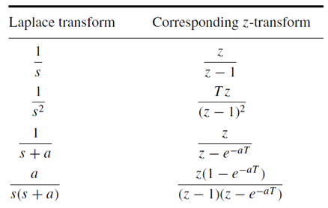

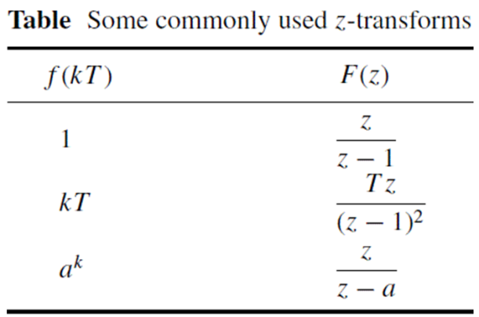



1. **Continuous to discrete-time state space transformation:**



1. **Controllability and observability matrices:**

